NorCal Collie Rescue
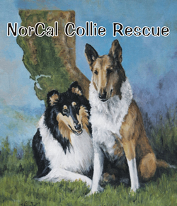
Adoption application

Pet ownership is a serious responsibility. The policy of NorCal Collie Rescue is to insure that each person who adopts a dog is aware of that responsibility and willing and able to accept that responsibility. A collie might not be the best choice of pet for everyone.

The following questionnaire has been designed to aid both you and us in determining if you (and your family) what kind of collie, if any, is the right choice for you.

Name: | Date:
Street Address: | City, State, zip:
Phone number(s): Preferred: | Best time to call:
Email Address:

Number of children & ages: *
Include grandchildren or other children under the age of 18 visiting regularly.
How long at current address: | Own / Rent*: |  |  | Home/Apt/Condo:
Where will the dog be primarily kept? | Explain:
If outside, what kind of shelter?:
Do you have a fenced yard |  | Describe:
Where will your dog sleep: |  | How many hours a day will your dog be left alone:
Have you previously owned a dog and if so what happened to the dog?:
What animals do you own now? List breeds, size, sex, age, altered, etc:
What is the name of your Veterinarian? |  |  | May we contact him/her for a reference?
Will you take your new dog to obedience class if we recommend it?

What is the primary reason you want a collie and what sex, age, color, and variety (rough or smooth) would you prefer?
Will you agree to a “home check” by a NCR volunteer?
If you have contacted a NCR volunteer already, please tell us who:
Any other comments or concerns or questions?

Please fill out this form in Word and email it to either: a) the closest Area Coordinator; b) the Area Coordinator whose dog you are interested in; or c) the general mailbox at: adoption@calcollierescue.org, as an attachment. We have provided this form using a table with boxes that you can type into. You may also snail mail it to your nearest Area Coordinator if all else fails.

Please call the NCR Collie Line: (650) 851-9227 if you have any questions.

